SOUTH COAST PRESBYTERIAN CHURCH

Ordinary people “continually praising “an extraordinary God
ISSUE SIX: 3rd MAY 2020

- Real Fears Surrounding COVID-19 and How God Answers Them All
By Kathryn Graves (Crosswalk Contributing Writer)
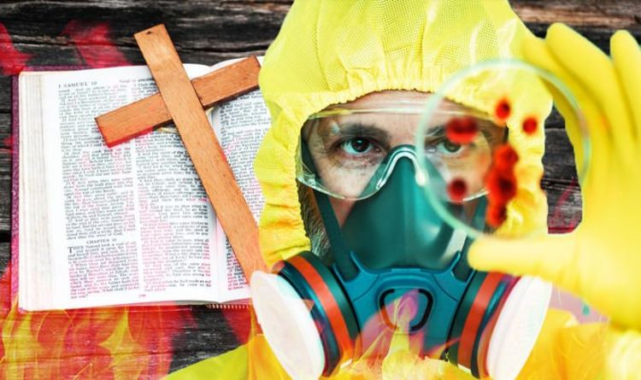Two months ago, life was rolling along pretty much as it had for our entire lifetimes. Oh, there had been ups and downs, but nothing we didn’t recover from.
Then suddenly everything changed with the arrival of the COVID-19 virus. Almost overnight our lives tumbled into an abyss of chaos and fragility.
Many fears and questions have surfaced, but there seem to be no solid answers from our civil leaders. However, in times like these, we can turn to the Lord for help.
Let’s examine a few of our collective anxieties and discover real help from the Bible.
1. My Own Health
Because this disease is new, nobody really knows how to prevent it. Hygiene advice streams to us in a constant barrage, but even this evolves with changing medical information.
We have no real assurance all our efforts will work. But at the same time, we don’t need to pretend a risk doesn’t exist. Ignoring this reality—even flaunting it—is unwise behaviour.
In Luke 12:6-7, Jesus told his disciples not to be afraid for their lives. While we are being careful, we can also be confident that God has a purpose for us and is paying attention to what happens—indeed, is taking care of us. Each of us is valuable to Him.
One of the Hebrew names of God, El Roi, means The Strong One Who Sees, and another, Elohim, conveys The God of Power and Might. This God will protect each of His children. Just as with any other potential illness or calamity, we find our peace in the attributes of our Lord.
“What is the price of five sparrows—two copper coins? Yet God does not forget a single one of them. And the very hairs on your head are all numbered. So don’t be afraid; you are more valuable to God than a whole flock of sparrows.” Luke 12:6-7 (NLT)
2. Health of a Loved One
Our families are precious to us. As parents, we’d give our own lives to protect our children.
Adults often feel the same way about their elderly parents. Because this virus seems to attack our older population, concern over these fragile family members can turn into fear. But James 5:16 tells us that prayer is an effective tool.
When we don’t have the power to do anything else, we can pray—and thus release all the power of heaven to work on behalf of our loved one.
The Bible is filled with examples of answered prayers for sick or dying—sometimes even already dead—people. While you might not feel special, or extra righteous, your prayers will be heard if you confess your sins. Jesus is the one who confers righteousness upon repentance.
So pray with authority, because you have all of His authority inside you in the form of the Holy Spirit. Expect great things to happen as a result of your prayers—because God is just waiting to hear them and go to work.
“Confess your sins to each other and pray for each other so that you may be healed. The earnest prayer of a righteous person has great power and produces wonderful results.” James 5:16 (NLT)

​​​​​3. Current Loss of Income and or Job
As a result of stay-at-home orders issued, businesses have shuttered and many jobs disappeared. Even if you still have your job, you may not be sure it will survive in the long term.
And you may be prevented from working and earning money until you can return to it. Promised financial help from the government might not come—or be enough to meet all your responsibilities.
When desperation closes in, remember God’s character and His promises. In the Lord’s Prayer (Matthew 6:11), Jesus instructed us to ask for our daily food. And in Genesis 22:14, Abraham gave God the name meaning “The Lord will provide.”
Abraham had learned he could trust God to provide the deepest longings of his heart. We can, too. It is during times like these, when we can’t trust anyone or anything else, that the Lord does His best—and often miraculous—work.
“Abraham named the place Yahweh-Yireh (which means “the Lord will provide”). To this day, people still use that name as a proverb: “On the mountain of the Lord it will be provided.” Genesis 22:14 (NLT)

4. Economic Future of Our Country and the World
It’s not just our own jobs and income sources that concern us. The entire world has been impacted in ways we may never recover from. At least, things may not return to pre-pandemic norms.
Trade relations will change, and globalism will likely suffer. Supply chains for certain goods may be interrupted while manufacturing capabilities relocate.
Prices for necessities will fluctuate. Ezra 8:23 records how when the Israelites were about to depart Babylon for their return trip to Jerusalem, they prayed for God’s care over them. They didn’t know what they’d find, or how they’d fare, after seventy years away.
Just like God heard their prayers, He’ll hear ours. One key to note in this verse is that the Israelites spent time fasting before and during their prayer. Now more than ever, we need to recover the lost power of fasting with prayer.
“So we fasted and earnestly prayed that our God would take care of us, and he heard our prayer.” Ezra 8:23 (NLT)

5. Inability to Gather for Corporate Prayer and Worship
We chafe against the rules forbidding corporate worship. We feel disconnected from our churches.
Watching the sermon online is just not the same as being together to sing and pray. Even Jesus went to the Temple during prescribed prayer hours. But Jesus also began a pattern he wanted his followers to imitate when he went off by himself to pray.
In Matthew 6:6, He stated the need for solitary prayers. Part of his reasoning was to prevent praying simply to be heard by others. These prayers are sometimes given in worship services.
They sound beautiful, but are merely empty words meant to impress people. We can take this opportunity apart from crowds to focus on and enrich our personal prayer life. Then when we gather together again, our public prayers will be even more meaningful.
“But when you pray, go away by yourself, shut the door behind you, and pray to your Father in private. Then your Father, who sees everything, will reward you.” Matthew 6:6 (NLT)
6. Loss of Civil Freedoms
Citizens are worried about restrictive rules banning certain public behaviour. It seems as if our rights are being unnecessarily violated in the name of “flattening the curve.”
The early Christians were familiar with having their rights trampled upon. Paul was a Roman citizen and ultimately took his case all the way to Rome for resolution.
In Colossians 4:3, he penned a unique view of his situation. He saw it as an opportunity to share the gospel. While we do need to work toward preserving our Rights in this country, we also need to recognize that a bigger picture may be at stake.
Whatever the legal issues, God wants to use you and me to spread the Good News to everyone with whom we come in contact. And He just might engineer our circumstances to “help” us meet some surprising people.
“Pray for us, too, that God will give us many opportunities to speak about his mysterious plan concerning Christ. That is why I am here in chains.” Colossians 4:3 (NLT)
7. Social Chaos
Social unrest can lead to chaos. If the government appears to be either inept or wrong in dealing with the crisis, people could begin resisting laws.
One thing we need to remember now is that God governs all civil authorities.
1 Timothy 2:2 tells us to pray for those in our government. We’re to pray not only for them as people who need Christ, but as keepers of the peace. When we entrust our leaders to the Lord, and ask Him to guide them and grant us quiet, dignified lives, we honour His higher rule over any human being.
“Pray this way for kings and all who are in authority so that we can live peaceful and quiet lives marked by godliness and dignity.” 1 Timothy 2:2 (NLT)
8. Children’s Education Shortfalls
Only in the last hundred years or so has public education become the way we teach our children.
Prior to that, it was the job of the family, or possibly the local community. Ruth became the mother of Obed as a result of her obedience and God’s intervention in her life.
Recognizing this truth, the women spoke a blessing over little Obed, as recorded in Ruth 4:14. These women helped Ruth raise Obed. He grew up to become the grandfather of King David.
We also have a redeemer for our families—and His name is Jesus. He will provide the resources we need to teach our children the most important concept: Repentance toward Jesus Christ and living under His Lordship.
Our children might lack a few hours a day of instruction from their schools, but right now parents have a golden chance to add Bible to the curriculum. Some might even decide to home-school on a permanent basis.
“Then the women of the town said to Naomi, “Praise the Lord, who has now provided a redeemer for your family! May this child be famous in Israel.” Ruth 4:14 (NLT)
9. Loneliness from Isolation
One of the effects of stay-at-home mandates is the rise of suicide and problems with addiction. Even those who don’t suffer from severe depression struggle with maintaining mental health.
In some places, it’s against the executive orders to even go outside for a walk. What is a person to do? The Bible tells us.
1 Kings 19:4 records the suicidal depression Elijah suffered as a result of feeling isolated. In verse 6, God sent him food and water. Then in verses 12-16, God spoke to Elijah and gave him a job to do—a purpose for living.
Elijah had been looking for God in dramatic events. But instead, He came in a whisper. The message for Elijah was to get enough good food to sustain him and stop looking for God’s purpose in something big—go do the normal stuff he did in his job as a prophet.
The message to us is the same. Get up every morning, eat nutritious food, and look for God’s purpose in the small, everyday things.
Listen for the whisper.
“…And after the fire there was the sound of a gentle whisper.” 1 Kings 19:12 (NLT)
10. Fear of the Unknown “New Normal” Future
What will the “new normal” look like? Life is certain to be irreparably different from what felt comfortable only a month ago.
Our unsettled feelings stem in part from the rapidity of the changes we’ve undergone. We fear that what we don’t know about the future could be worse. Revelation 21:5-7 tells us that God is in the process of making everything new.
His “new normal” will be unimaginably fantastic for believers. It is something to anticipate with joy rather than fear.
We can be calm and at ease about it because our relationship with God is that of a parent to his child—and we can trust our Heavenly Father to prepare the best for us. The transition might be uncomfortable, but the end result will be worth it.
“And the one sitting on the throne said, ‘Look, I am making everything new!’ And then he said to me, ‘Write this down, for what I tell you is trustworthy and true.’ And he also said, ‘It is finished! I am the Alpha and the Omega—the Beginning and the End. To all who are thirsty I will give freely from the springs of the water of life. All who are victorious will inherit all these blessings, and I will be their God, and they will be my children.’” Revelation 21:5-7
Whatever may come, we have the assurance that God is with us and He will take care of us. Prayer opens up power from heaven and reveals earthly help we hadn’t seen or realized before.
The old song, “God Will Make a Way” is really true—even when there seems to be no way.
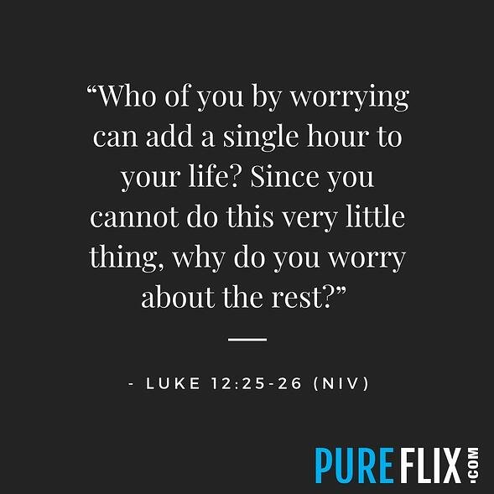
A PRAYER
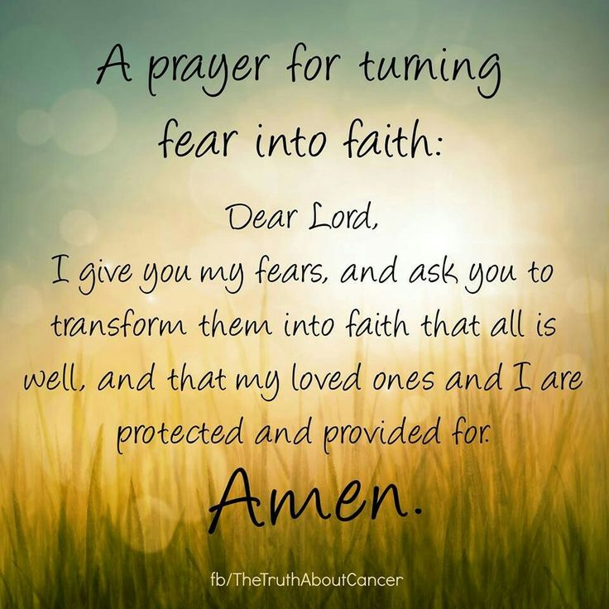

RECIPESThis week I have included a Chocolate Brownie Recipe Tom and I discovered when we stayed at the historical Palmer House in Chicago. They still make it at Palmer House and we both tasted them and found them delicious.
BIBLE TRIVIA
1.How many times is Peter mentioned in the Bible?
Answer:

2. What was the name of the notorious prisoner released at Passover instead of Jesus?
Answer:

3. How many books in the New Testament?
Answer:

4. What type of insect did John the Baptist eat in the desert?
Answer:

5. Who were the first apostle to follow Jesus?
Answer:
{Answers next week}
week five answers
1 What four fishermen became disciples of Jesus?
Answer: Peter, Andrew, James and John

2. According to the commandment five, who should you honour?
Answer: Honour your father and mother

3. What is the first one of the ten commandments?
Answer: You shall have no other god’s before Me.

4.Where was Jesus born?
Answer: Bethlehem.

5.The last book of the Bible refers to the serpent as what?
Answer: Satan.

One legend about the creation of brownies is that of Bertha Palmer, a prominent Chicago socialite whose husband owned the Palmer House Hotel. In 1893 Palmer asked a pastry chef for a dessert suitable for ladies attending the Chicago World's Columbian Exposition. She requested a cake-like confection smaller than a piece of cake that could be included in boxed lunches. The result was the Palmer House Brownie with walnuts and an apricot glaze. The modern Palmer House Hotel serves a dessert to patrons made from the same recipe. The name was given to the dessert sometime after 1893, but was not used by cook books or journals at the time.
The Palmer House Chocolate Brownie
Ingredients:
14 oz (400g). semi-sweet chocolate
1 lb.(450g) butter
12 oz.(340g) granulated sugar
4 oz.(115g) flour
8 eggs
12 oz (340g). crushed walnuts
Vanilla extract
Directions:
1. Preheat oven to 300 F / 150C.
2. Melt chocolate and butter in a double boiler. Mix the sugar and flour together in a bowl. Combine chocolate and flour mixtures. Stir 4 to 5 minutes. Add eggs and continue mixing. ​
3. Pour mixture into a 9x12” (22 x 30cm) baking sheet. Sprinkle walnuts on top, pressing down slightly into the mixture with your hand. Bake 30-40 minutes. ​
4. Brownies are done when the edges begin to crisp and has risen about ¼” of 5mm. ​
Note: When the brownie is properly baked, it will remain “gooey” with a toothpick in the middle due to the richness of the mixture.
Glaze: Mix together 1 cup water, 1 cup apricot preserves, and 1 tsp. unflavoured gelatine in sauce pan. Mix thoroughly and bring to a boil for two minutes. Brush hot glaze on brownies while still warm.
MUSIC

The original words to the hymn date back as far as 6th Century Ireland, and to the prolific Irish writer Dallan Forgaill (c.530-598), with the original title 'Rop tú mo Baile'. It is said that such was his zealousness for writing poetry and studying that it led to his blindness.

BE THOU MY VISION
Be Thou my vision, oh Lord of my heart
Naught be all else to me, save that Thou art
Thou my best thought by day or by night
Waking or sleeping, Thy presence my light
Be Thou my wisdom and Thou my true word
I ever with Thee and Thou with me, Lord
Thou my great Father, I Thy true son
Thou in me dwelling and I with Thee one
High King of Heaven my victory won
May I reach heaven's joys, oh, bright heaven's sun
Heart of my own heart whatever befall
Still be my vision, oh Ruler of all
Thou and Thou only first in my heart
High King of Heaven, my treasure Thou

https://youtu.be/v5sQZs4ZF_0?t=10

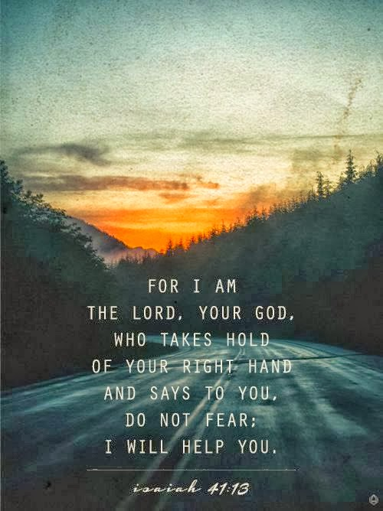

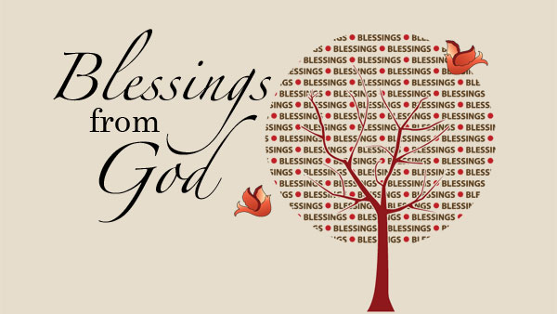e.co

