SOUTH COAST PRESBYTERIAN CHURCH

Ordinary people “continually praising “an extraordinary God
ISSUE SEVEN: 10th MAY 2020

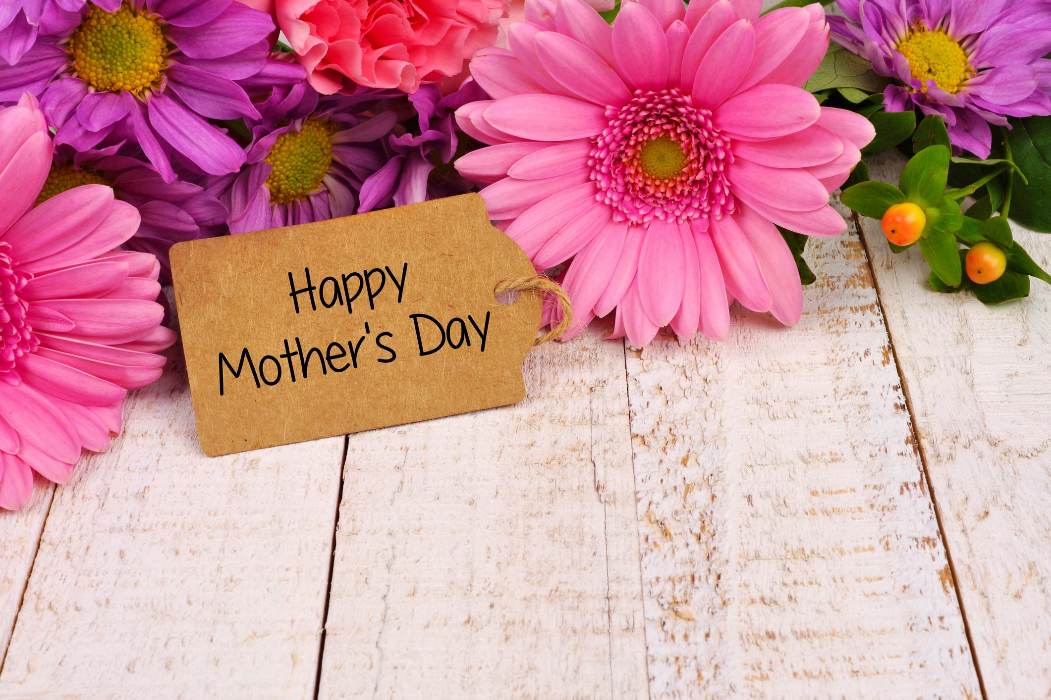

Happy Mother’s Day to all our mothers.
I have included two articles today the first one focusing on one mother in the bible and the lengths she goes to in the protection of her child and the second a more comedic view looking at six mothers in the Bible.

A model for motherhood
K. Allan Blume, (Biblical Recorder Editor)

When God designed motherhood, He gave the world one of His most unique creations. No human role elicits as much emotion as that of a mother. It is not surprising that Mother’s Day generates a massive tidal wave of respect and attention toward our mums. It is a big day for the greeting card industry, phone companies, and it might even help pull the post office out of their deficit.
Yet, none among us claims to have the perfect mother, and I don’t know any mums who want to claim the title “perfect mum.”
Most mums do their best to give sacrificially and love unconditionally 24-7. But they hit the wall sometimes with a feeling of inadequacy, wondering if they did the right thing.
While mothers are great examples to us, they need models of their own to follow. God has given the world some great ones!
One of my favourite motherly models is Jochebed, the mother of Moses. I would call her a “super-model” – obviously not in the secular sense.

Jochebed is mentioned only a few times in scripture, but she provides a finely drawn portrait of a mother with great faith. The second chapter

of Exodus pictures her as a woman of decisive, courageous and sensible faith.
She was decisive in the way she planned a strategy to save her son.
Because the Hebrew people had become a threat to Egypt’s reigning Pharaoh, he forced them into rigorous slavery. When they continued to grow and prosper, he commanded the Hebrew midwives to throw their newborn sons into the Nile to die.
It was during this political reign of terror that Jochebed gave birth to her third child, Moses. He was born into a world where the government devalued life and forced infanticide. That is not an acceptable option for a woman of faith.
You know the story of how she constructed a basket. She placed her baby in the basket, and carefully deposited it in a river near the bathing spot of the Pharaoh’s daughter. Then she waited.
In the dangerous world in which she lived, Jochebed stands out because she did what she could to save her child. Being a mother isn’t for the faint of heart. It requires some tough decisions – decisions that are risky and heart-wrenching. Such decisions require faith in God’s almighty hand. She did what she could do and trusted God for what He could do.
Jochebed was courageous in the way she committed to save her son’s life. She would have to go against the law of the land. She would risk her own life as well as her newborn son’s life. Courageously, she followed divine law. Jochebed and her husband disobeyed the government and hid Moses for three months. That takes courage!
This woman is also a model of sensible faith. When it was obvious that little Moses could not remain hidden from the authorities, she did not throw the child haphazardly into the Nile River.
She chose the specific place where Pharaoh’s daughter would bathe, and she placed Moses’ sister, Miriam, close by to watch the situation.
Miriam was poised to be available to Pharaoh’s daughter when the opportunity came. What a sensible act by Moses’ mother!
Every conscientious mother knows how dangerous it is to raise a child in our world. Children must be guarded and protected from forces intent on destroying them. Mothers are designed for such an assignment.
Mothers, you are loved and appreciated. You have a lot on your plate, and you have a big responsibility. Follow biblical models for motherhood.
Your children are blessed and all of society is stronger because you obeyed God. We need you!

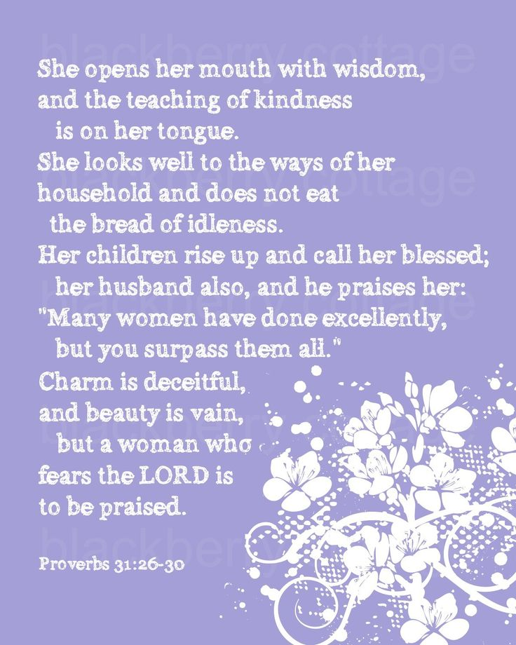

Six Amazing Mums in the Bible
By Anita Renfroe
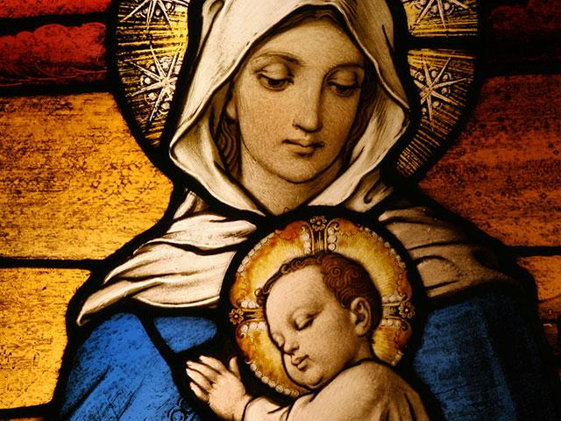

If you have spent your adult life trying to live up to the mothering standard set in the thirty-first chapter of Proverbs (and I know some women do), you might as well just go ahead and take up permanent residence in the I-can’t-quite-measure-up lane. I have a sneaking suspicion that that woman was either a composite sketch of several stellar women, a wishful hope, or a case of one woman mistakenly believing her own press kit.
The intro to that chapter of Proverbs states that these are “the sayings of King Lemuel — an oracle that his mother taught him.” Webster defines this sort of oracle as “a person giving wise or authoritative decisions or opinions.” I would amend that to say that this was likely a mother hoping none of the girls her son was currently dating would ever measure up to her “oracle.” Regardless, we are left with the impression that this sort of mother is the Approved Standard Version — family centered, good business woman, great cook, generous, prepared, discreet, praiseworthy, wise, and beautiful. If she was indeed a real woman — all things to all people and extraordinarily perfect — then I’m just glad we didn’t have a chance to meet. She could never have considered me as part of her Potential Friend Pool.
This is precisely why I am so glad that the Bible gives us pictures of other kinds of mothers — the ones who cause us to nod our head to affirm the phrase, “If you can’t be a good example then you’ll just have to be a horrible warning.” I have come up with examples of a few of both types in the following list. There are many other moms in God’s Word, but these are a sampling of the good, the bad, and the downright bizarre.

EVE
The Original Mother — more specifically, of Cain, Abel, and Seth (and several unnamed others)
I guess if we are to commence in chronological order we would have to begin with Eve, the mother of us all. And she was the woman who made THE monumental, mind-blowing, affects-everybody forever mistake. So, she probably deserves the bad rap she gets. But it wasn’t like there were any other women around to make it instead of her, right? Maybe she was the first to partake of the fruit just because she was the only one who could remember where it was in the garden (women just know where stuff is). You have to feel a little bit of sympathy for the girl who didn’t have a mother to ask about how things were for her back in the day. When the kids had a temperature or were teething, she just had to figure it out on her own, but, then again, nobody could look at her and tell her that she was doing it all wrong. And sure, she got us into epidurals, but she had the mother of all heartache, too. Her sons were involved in the first homicide (without Nintendo and violence on TV to blame it on). She was the first mom to have to bury her child.

SARAH
Mother of Isaac
This is the mom who gives hope to everyone who waited a little late to get started on the Mommy Track. Not that she didn’t try; her womb was just on a different biological clock. God made a promise to Abraham that he would be the father of many nations. This led Sarah to the logical conclusion that she would be the mother of many nations. When that wasn’t happening in a timely manner, Sarah decided to do her own "thang," so to speak. She gave her handmaiden Hagar as her maternal stunt double. This resulted in a child but not the child. When the messenger of the Lord told Abraham that it really would be Sarah that was going to deliver the promised baby, Sarah overheard, laughed, and promptly got in trouble for it. But if you were her age you would laugh, too, just thinking about how the breast-feeding would be easy now that she could just lay Isaac on her lap to do it. Sarah is a sister who could laugh at her late start with motherhood knowing that good things come to those who wait.

REBEKAH
Mother of Jacob and Esau
For every mom who has ever had the temptation to play favourites with her children, pay attention to Rebekah. She didn’t just play favourites, she schemed and connived and was an accessory to one of the biggest Daddy Dupes in all of history. It says it plain in Scripture that Isaac loved Esau because he was an outdoors-man but Rebekah loved Jacob. This kind of favouritism does not bode well for a family. When the lines are drawn and it is obvious who is thick with whom, life can get very messy. Rebekah was in collusion with Jacob (even his name meant “trickster”) to take the birthright from his older brother. I’m sure she rationalized that it wasn’t such a bad thing since the twin boys were only separated by moments, but her hand in helping Jacob trick his father was her way of thumbing her nose at the order of things and a diss to her dying husband. Turns out that this family rift lasted for a long time. Rebekah reminds us that it is a dangerous thing to use maternal power for manipulation.

BATHSHEBA
Mother of Solomon
Bathsheba was well-named as it was her “bath-ing” that attracted the attention of King David. Their illicit affair resulted in the birth of a son. David tried for some damage control by sending her husband out to war, back to the house hoping for a copulating cover-up, and then out to the frontlines to get killed. (And we think we have seriously evil plots in our current movies.) David got his wish — Bathsheba’s husband was killed in battle, and David thought he had gotten away with it. Nathan confronted him and David repented bitterly. But we never really hear how it all
affected Bathsheba. Their sin is well documented and the effects to David’s household long-lasting. However, a son was born from their union and Solomon turned out to be a peaceable ruler whose wisdom was legendary. Bathsheba’s motherhood gives women hope that, regardless of the circumstances surrounding your pregnancy and the birth of your child, God can redeem any situation. You never know, you might just have the wisest person ever on the planet staring back at you from that high chair.

JOCHEBED
Mother of Aaron, Moses, and Miriam
If there was ever a mom whose life would have made a great screenplay for a Lifetime for Women movie it would be Jochebed. You just have to give it up for her and the midwives who, in their act of civil disobedience, allowed Moses to be born. Those midwives, when asked by the pharaoh why they were not killing the boy babies as commanded, replied that the Hebrew women were “too vigorous” and popped those babies out before they could get there! Thus, baby Moses was born but had to be sent down the river (literally) with his sister serving as lookout, only to be pulled out of the water by the pharaoh’s daughter, who secured the services of Moses’ biological mom to nanny him. Talk about movie script material! Oh wait. They’ve already done that. Anyway, Moses’ mom shows us that the determination and ingenuity of a desperate mother can result in surprising circumstances. Oh, the places you’ll go!

MARY
Mother of Jesus
Talk about your Personal EPT . . . I mean Mary’s was early, EARLY! And accurate, too. Angelic visitation definitely qualifies as a sure thing. But the favoured girl had to have some concerns because unwed pregnancy was a little different back then. You could get stoned for it. I’m sure she was very relieved to find out that the angel had given her beau, Joseph, the same message. And yes, she was going to give birth to the divine Gift of heaven, but, as any mother knows, all gifts come with some work attached. She still had to change the Baby Jesus’ diapers, soothe him as he teethed, teach him to walk, and clean up his skinned knees. She had to cook the meals and wash his clothes and do all the things that moms do for their children. It’s interesting the places we see Mary pop up in the gospels — for example, at the temple sending out an APB for her boy. (I believe I might have grounded Jesus if he told me that he was just doing his father’s business, but no such reaction from Mary is recorded.) Another of my favourite mother moments of Mary’s was when she was at the wedding feast apparently exasperated with her thirty-year-old son for not doing that “thing” he could do with the water. When Jesus seems to refuse to come through the way she knows he can, she goes around him and tells the servants to get ready to do something for him. And Jesus does the miracle. I would have loved to have been there to see the looks pass between mother and son that night. And then we see Mary at the crucifixion. Disciples may scatter, followers may be in hiding, but a mother stays when the rest of the world walks away. In fact, Mary is a rich tapestry of real motherhood: a lot of excitement followed by years of work and moments of intense pain. But through it all, mothers are there.
These moms in the Bible reveal to us that mother-love is fierce and stubborn to a fault — even wrong-headed sometimes. We do right things for wrong reasons and wrong things because we think everyone needs our help. When you look at the moms in the Bible say a silent prayer of thanks that these women are included alongside the Oracle of Lemuel in Proverbs 31 to bring snapshots of reality and spiritual caution cones to our journey.

About the Author
Described as a "shot of espresso in a decaf world," Anita Renfroe is a highly original, spontaneous, and unashamedly real comedian, musician, and author.

A PRAYER
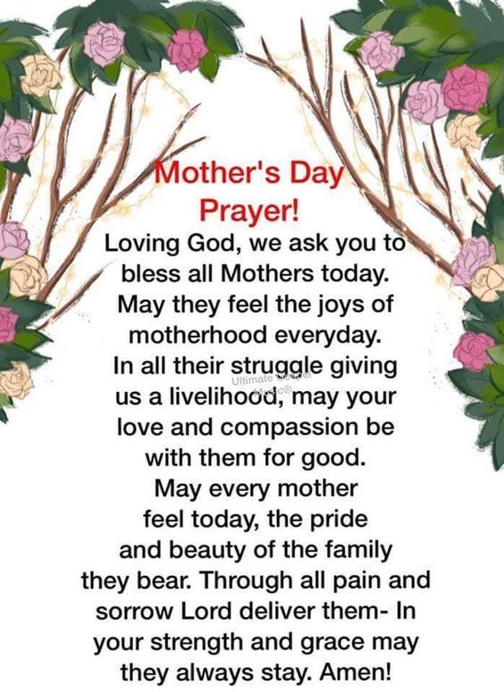
You are my sunshine by Susan Boyle
https://www.youtube.com/watch?v=vr1ikIJYrGU&feature=youtu.be

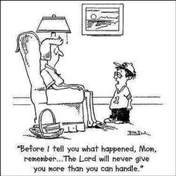

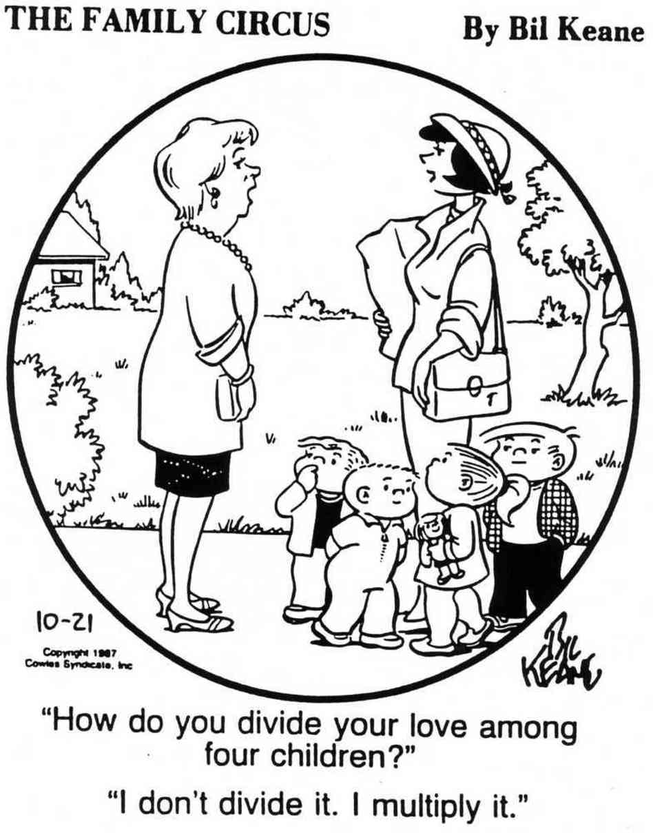
RECIPES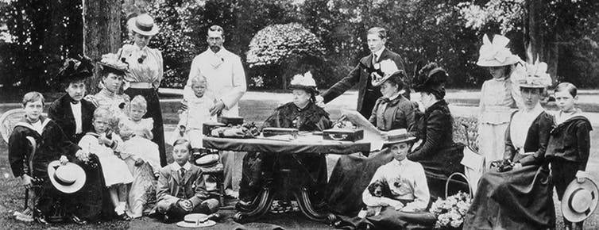
BIBLE TRIVIA
1 How many people did Jesus feed with the5 loaves of bread and 2 fishes?
Answer:

2 After Jesus was arrested, which apostle disowned him three times?
Answer:

3 Who recognized Jesus as the Messiah when He was presented at the Temple as a baby?
Answer:

4 Who asked Pilate for Jesus’s body after the crucifixion?
Answer:

5 Paul was shipwrecked on what Island?
Answer:

{Answers next week}
week five answers
1.How many times is Peter mentioned in the Bible?
Answer: 157

2. What was the name of the notorious prisoner released at Passover instead of Jesus?
Answer: Barabbas

3. How many books in the New Testament?
Answer: 27

4. What type of insect did John the Baptist eat in the desert?
Answer: Locusts

5. Who were the first apostle to follow Jesus?
Answer: Peter and Andrew

Sponge cakes became the cake recognized today when bakers started using beaten eggs as a rising agent in the mid-18th century. The Victorian creation of baking powder by English food manufacturer Alfred Bird in 1843 enabled the sponge to rise higher than cakes made previously, resulting in the Victoria sponge, Queen Victoria’s favorite cake.
VICTORIA SPONGE
Ingredients
- 4 free-range eggs
- 225g/8oz caster sugar, plus a little extra for dusting the finished cake
- 225g/8oz self-raising flour
- 2 tsp baking powder
- 225g/8oz butter at room temperature, plus a little extra to grease the tins
- good-quality strawberry or raspberry jam
- whipped double cream
Method
- Preheat the oven to 180C/160C Fan/Gas 4. Grease and line two 20cm/8in sandwich tins. Line the bottom with a circle of baking paper.
- Break the eggs into a large mixing bowl, then add the sugar, flour, baking powder and butter. Mix together until well combined with an electric hand mixer, but be careful not to over mix. The finished mixture should fall off a spoon easily.
- Divide the mixture evenly between the tins: gently smooth the surface of the cakes.
- Bake the cakes on the middle shelf of the oven for 25 minutes. Check them after 20 minutes. The cakes are done when they’re golden-brown and coming away from the edge of the tins. Press them gently to check – they should be springy to the touch. Set aside to cool in their tins for 5 minutes.
- To assemble the cake, place one cake upside down onto a plate and spread it with plenty of jam then spread over the whipped cream. Top with the second cake, top-side up. Sprinkle with caster sugar.

